RT-DETR Performance Report on WaRP-D

Objective
To analyze the detection performance of RT-DETR on the WaRP-D dataset using Ultralytics, with a focus on high-confidence (conf=0.6) validation for deployment-ready results.

Experiment Settings
Training configuration:
Model: RT-DETR-l, pretrained on COCO for strong starting weights.
Epochs: 150 full passes through the data for thorough learning.
Batch size: 16 images per step, balancing speed and stability.
Image size: All images resized to 640×640 for consistent input.
Augmentations:
Mosaic 0.5: Combines 4 images for variety (50% of batches).
Mixup 0.1: Blends 2 images (10% of batches).
HSV h=0.02, s=0.8, v=0.5: Color/brightness changes for robustness.
Learning rate: 0.001 for stable, gradual weight updates.
Label smoothing: 0.1, to reduce overconfidence and handle label noise.
Early stopping: Off (patience=0), always trains all epochs.
TTA: Enabled at validation for more robust predictions.
Result snapshot:
- mAP50: 0.583
- mAP50–95: 0.477
Training Results (Best Model):
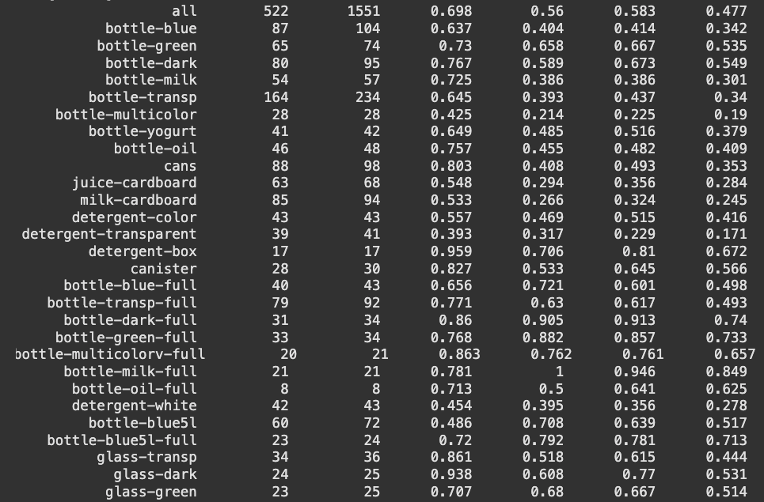

2. Validation Phase

Validation Experiment :
results = model.val(
data='/kaggle/working/data.yaml',
imgsz=640,
conf=0.6, # Only keep predictions with 60%+ confidence
augment=True # Test Time Augmentation for extra robustness
)
Result snapshot:
- mAP50: 0.648
- mAP50–95: 0.548
At conf=0.6, only detections with >60% confidence are kept, giving results that focus on the model’s most certain predictions. This increases precision and is suitable for real-world deployment scenarios.

Why Use conf=0.6?
Keeps only predictions with 60%+ confidence, reducing false positives and making results more reliable.
Benefits:
Higher precision (fewer “junk” boxes), cleaner outputs.
More trust for real-world use (e.g., recycling robots, quality control).
mAP50/mAP50–95 reflect only the most certain detections.
When to Use:
In production or deployment, where mistakes are costly and precision matters more than catching every possible object.
Future Work:
To further improve:
Try more/different augmentations
Test other confidence levels (0.5, 0.7)
Use TTA for extra robustness

Validation Results:

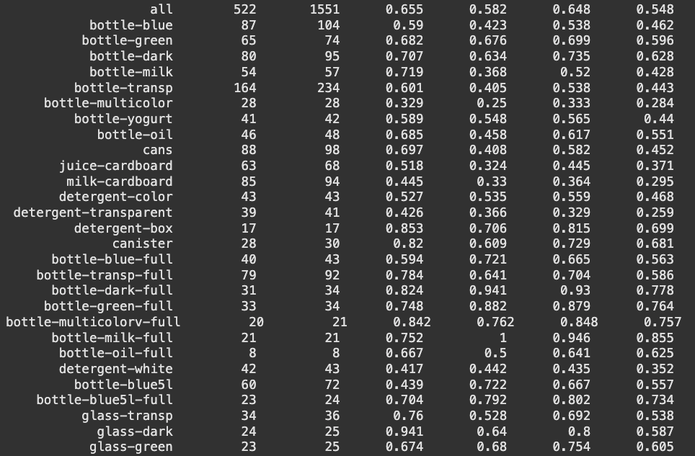

Conclusion
RT-DETR-l delivers robust and high-precision results, especially at high confidence (conf=0.6). Always monitor both overall and per-class metrics to fully understand model performance.

